Test RE  
Spring 2023  
Subject: WED201c  
Duration: 120 minutes

**Objectives:**

* Create a style sheet file and link it to the html file.

**Background:**

* In this practice exam, you are given a folder “**Resource**”. You are going to use page “index.html” to finish the exam. **You don’t be change image and not used framework Bootstrap.**
* After completing the final exam, The student will submit the **Resource folder** to the Server.

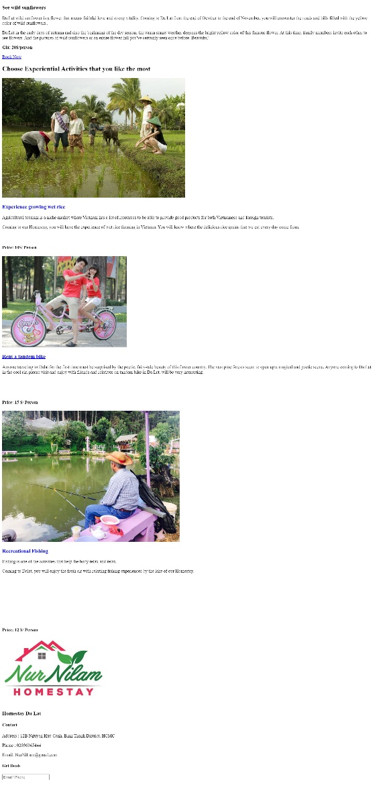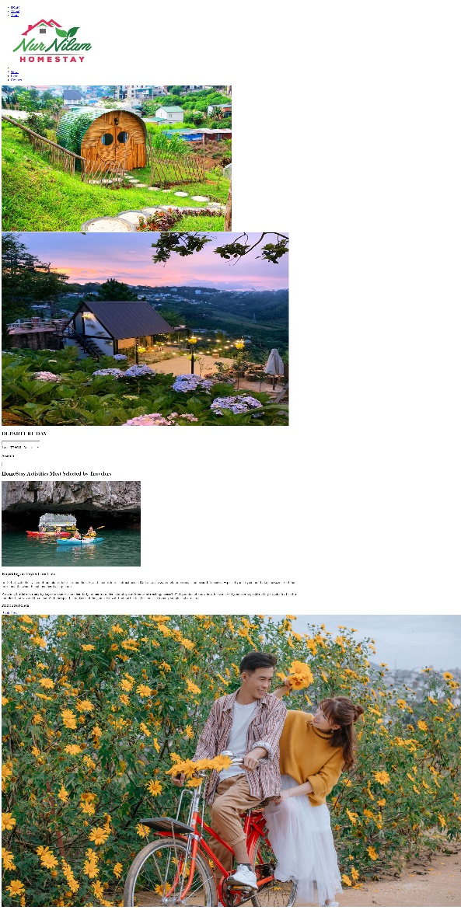**Before styling index.html page**

Scroll

**After styling index.html page**



**Required:**

1. Create a file called styleindex.css to format the index.html page and save it to the **Resource/CSS folder**.

**Evaluation**

**A. HTML [0.5 points]**

* Embed the styleindex.css file in the head tag of the index.html page [0.5 points ].

**B. CSS [ 9.5 points]**

* Use margin and padding to create the right spacing for the content [1 point ].
* Use css to format the menu as shown above [ 1 point].
* Use css to format the logo as shown above [ 0.5 points ].
* Use css to format the banner as shown above [ 0.5 points].
* Use css to format the “DEPARTURE DAY” content [ 1 point ].
* Use css to format for titles [1 point].
* Use css to format the “HomeStay Activities Most Selected by Travelers” content [ 2 points ].
* Use css to format the “Choose Experiential Activities that you like the most” content [ 1.5 points].
* Use color and background to format for the “footer” content [ 1 point] .

**The end**